**10/04/2017**

**Donport4 Setup Soup to Nuts**

These are things to do on a Win 10 machine, where Windows 10 has just been installed.

Set up power settings so that things stay up forever, if the PC is plugged in.

Set up Wi-Fi for speedy Internet Access for everything else.

After they become available, look for missing items in Software Tab in Gmail, or in Dropbox/setups.

Install Chrome. Register Google password. Shut off synching of passwords and browsing history.

Install XMARKS on Chrome. Connect to belldr/clamx123 account. Import bookmarks.

Create users/Don Bellenger/Dropbox. Install Dropbox from the web, and link it to that directory. Synching starts automatically, but takes OVERNIGHT.

Download TortoiseGit from the web. It will tell you to install Git for Windows 2.0, first, and provide a link. Here is my copy of git and Tortoise Git installed on 10/4/2017.

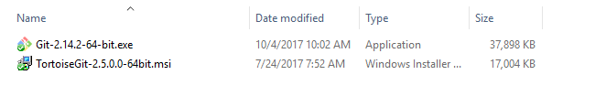

Install sublime text 3 from the web. (<https://www.sublimetext.com/download>).

To get the correct packages into Sublime, copy the highlighted directories from the Thumbdrive to C:\users\dbellenger\AppData\Roaming\Sublime Text 3

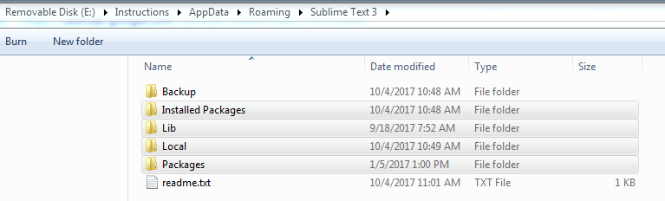

Install Araxis Merge from setup file in setups, and set File comparison options, and register from key in Gmail Software tab.

Windows Powershell is already installed

Install ConEmu Stable from web. Start it, and set to run over Powershell as Administrator. Instructions are at <https://conemu.github.io/en/ConEmuFAQ.html> . Right click the “Settings” at the right top, and click of colors, and pick Solarized Light scheme, but change color of the backcround to light gray, and the color of the response texts from red to lime green, and SAVE settings.

In powershell, to enable running scripts, run

Set-ExecutionPolicy -ExecutionPolicy RemoteSigned

**PMS-ES**

Ask Josh to install Oracle, and a copy of the LOCALDEV Oracle database onto the machine.

See **Steps for installing PMSES on a new machine** for instructions on installing Command Box, and then pmses.

**BBSG**

Install MySQL. Appears to use x86 version. Files are in setups/mysql.

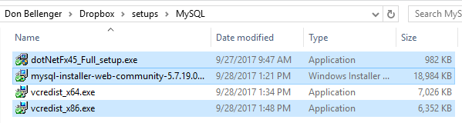

On windows 10, prerequisites are dot net 4.5, and c Redistributable 2013. Then run mysql_installer_web… as administrator multiple times to install the server, and the workbench, and the obdc drivers.

Install Navicat for MySql from the web. My license key seems to have expired.

**After installing CommandBox as per the instructions in the PMS-ES section, do the following.**

Clone code from github. Belldrfree. <https://github.com/>. Go to the uisdesign1-dev1 repository. Get the link for cloning bbsgdv1.

In c:\projects, right click on cbsites, and do a git clone with that link. This will make c:\projects\cbsites\bbsgdv1.